D.E.I. TECHNICAL COLLEGE, DAYALBAGH AGRA.

DIPLOMA IN INFORMATION TECHNOLOGY VOCATIONAL
  - VIT301 Software Development SESSION: 2023
Assignment-1 M.M. 25
Note: Write the Algorithm and Source Code of the following problems.
- Question
Write a Program in C convert temperature Fahrenheit to Degree Celsius.
- Question
Write a Program in C to find greatest of 3 integer values.
- Question
Write a Program in C to check whether a number is Even or Odd.
- Question
Write a Program in C to find whether a year is leap or not.
- Question
Write a Program in C to check whether a number is Prime or Not.
- Question
Write a Program in C Swap two values using 2 variables method.
- Question
Write a Program in C to find factorial of a positive integer value.
- Question
Write a Program in C to get table of any positive integer value.
- Question
Write a Program in C to find sum of digits.
- Question
Write a Program in C to check given number is Armstrong or not.

ROLL NO: 2305823 NAME: SOUMYA KUSHWAH
Program-1: Write a Program in C convert temperature Fahrenheit to Degree Celsius.
Algorithm: Fahrenheit to Celsius Conversion
STEP1. Start
STEP 2. Input the temperature in Fahrenheit (F).
STEP 3. Perform the Celsius conversion using the formula:
Celsius (C) = (F - 32) * 5/9
STEP 4. Display the converted temperature in Celsius.
STEP 5. Stop
Source Code and output screen: 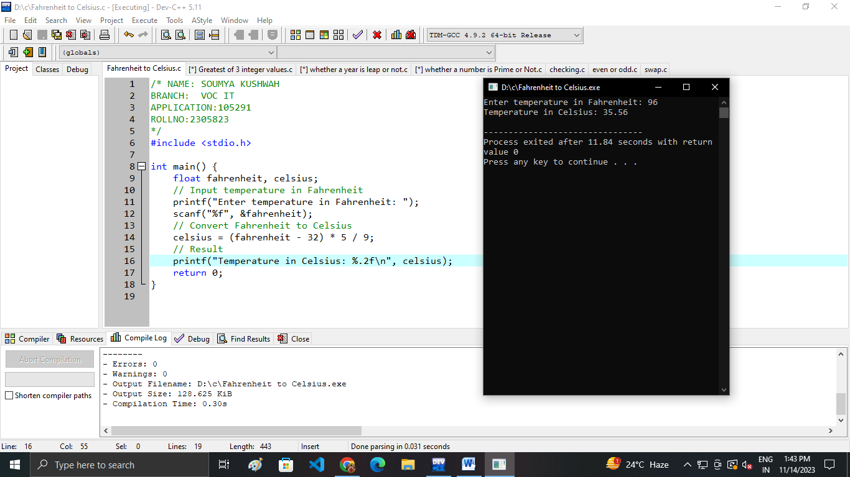
ROLL NO: 2305823 NAME: SOUMYA KUSHWAH
Program-2: Write a Program in C to find greatest of 3 integer values.
Algorithm: Find the greatest of three integers
STEP1. Start
STEP2. Input three integers (A, B, C) from the user.
STEP3. Check if A is greater than B and C:
  - If true, display A as the greatest.
STEP4. Check if B is greater than A and C:
  - If true, display B as the greatest.
STEP5. Check if C is greater than A and B:
  - If true, display C as the greatest.
STEP6. If none of the above conditions is true, the numbers are equal.
  - Display a message indicating that all three numbers are equal.
STEP7. Stop
Source code and output screen: 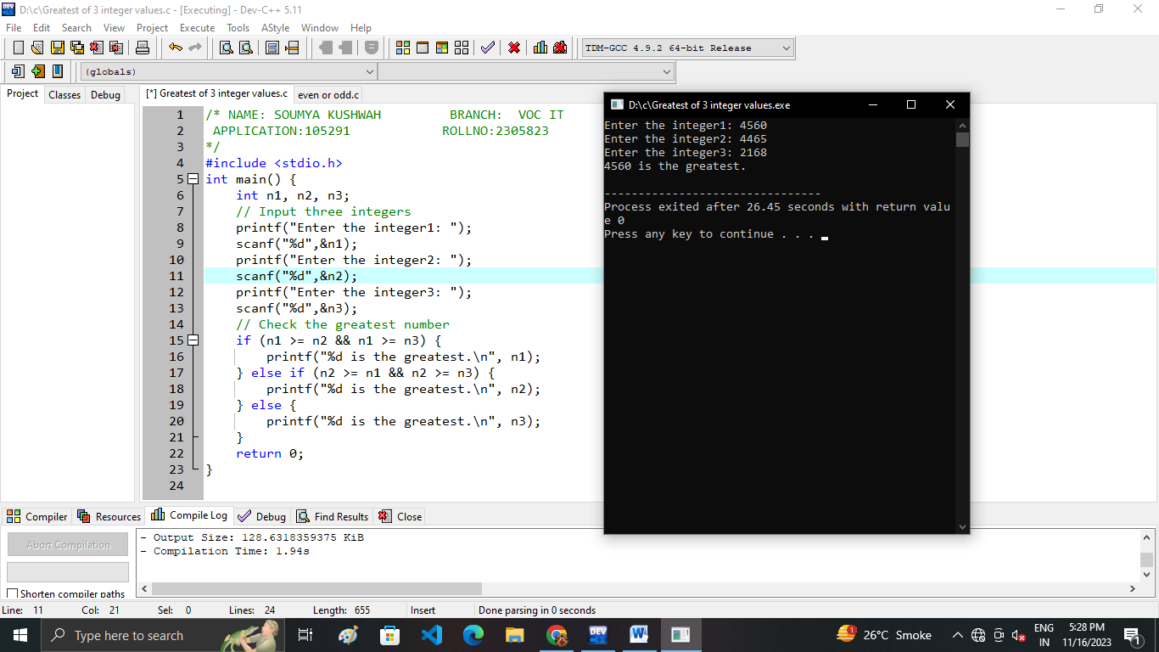
ROLL NO: 2305823 NAME: SOUMYA KUSHWAH
Program-3: Write a Program in C to check whether a number is Even or Odd.
Algorithm: Check Even or Odd
STEP1.Start
STEP2.Input an integer from the user and store it in a variable (n).
STEP3.Check if ‘n’ is divisible by 2 without a remainder:
  - If true, display "number is even."
  - If false, display "number is odd."
STEP4.Stop
Source Code and output screen: 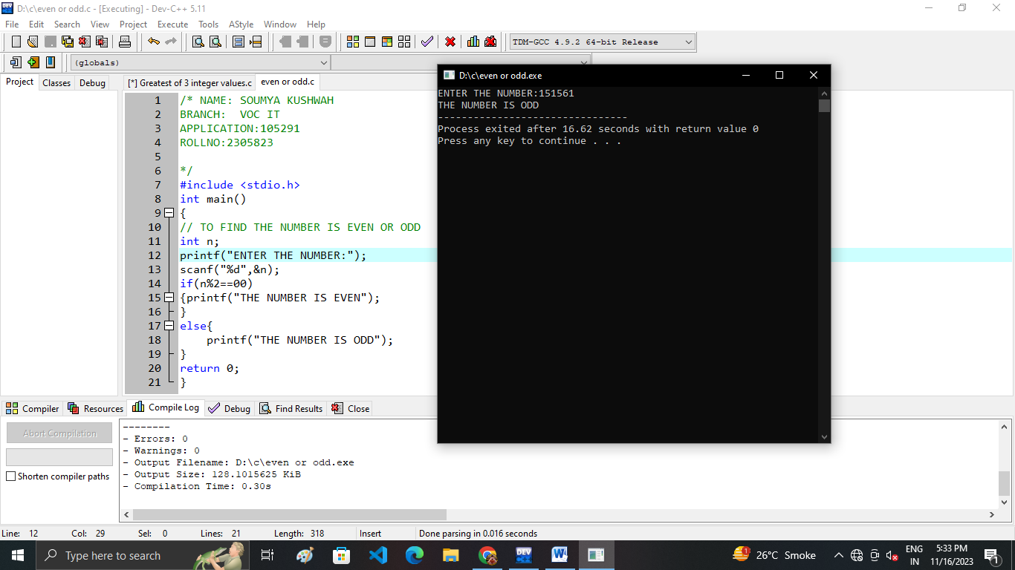

ROLL NO: 2305823 NAME: SOUMYA KUSHWAH
Program-4: Write a Program in C to find whether a year is leap or not.
Algorithm: Check the year is leap or not
STEP1. Start
STEP2. Input a year from the user and store it in a variable (year).
STEP3. Check if the year is evenly divisible by 4:
  - If true, go to step 4.
  - If false, go to step 7.
STEP4. Check if the year is evenly divisible by 100:
  - If true, go to step 5.
  - If false, go to step 6.
STEP5. Check if the year is evenly divisible by 400:
  - If true, display "Leap year."
  - If false, display "Not a leap year."
STEP6. Display “Leap year."
STEP7. Display “Not a leap year."
STEP8. Stop
Source Code and output screen:
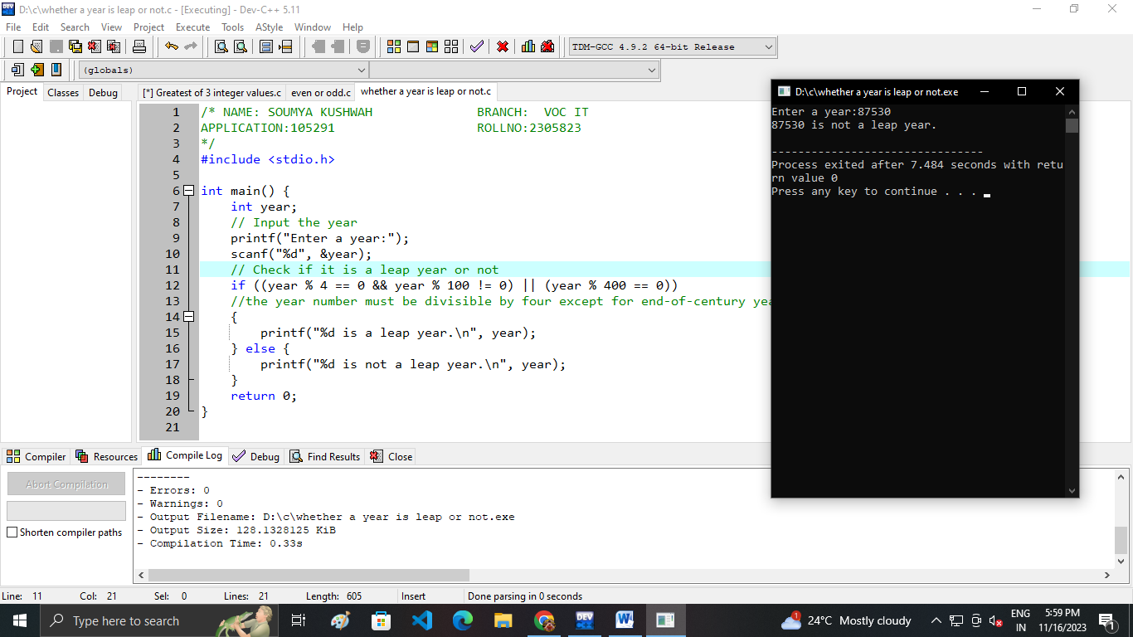
ROLL NO: 2305823 NAME: SOUMYA KUSHWAH
Program-5: Write a Program in C to check whether a number is Prime or Not.
Algorithm: Check the number is prime or not
STEP1.Start
STEP2.Input the number from user
STEP3.Check if ‘n’ is less than or equal to 1.
- If true, set ‘P’ to 0.
- If false, proceed to the next step.
STEP4.Initialize a loop variable i to 2 and iterate until i is less than or equal to the square root of ‘n’.
STEP5.Check if ‘n’ is divisible evenly by i (i.e., ‘n’ % i == 0).
- If true, set ‘P’ to 0 (Not a prime number) and break out of the loop.
- If false, increment i and continue the loop.
STEP6.Display the result based on the value of ‘P’.
- If ‘P’ is true, print "‘n’ is a prime number."
- If ‘P’ is false, print "‘n’ is not a prime number."
STEP7.Stop
Source Code and output screen:
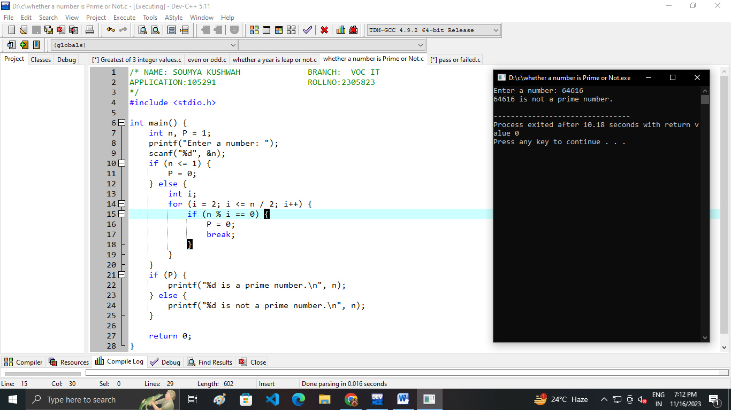
ROLL NO: 2305823 NAME: SOUMYA KUSHWAH
Program-6: Write a Program in C Swap two values using 2 variables method.
Algorithm: Swap Two Values Using 2 Variables
STEP1. Start
STEP2. Input the values of variable A and B from the user.
STEP3.Print the values before swapping: "Before swapping: A = [value of A], B = [value of B]".
STEP4.Perform the swap using arithmetic operations:
  - Set A = A + B
  - Set B = A - B
  - Set A = A - B
STEP5.Print the values after swapping: "After swapping: A = [new value of A], B = [new value of B]".
STEP6.Stop.
Source Code and output screen:
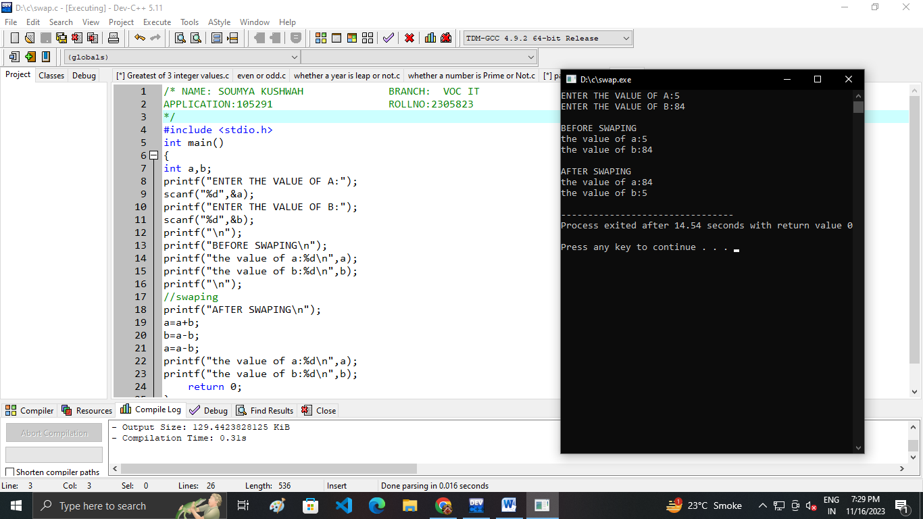
ROLL NO: 2305823 NAME: SOUMYA KUSHWAH
Program-7: Write a Program in C to find factorial of a positive integer value.
Algorithm: Calculate the factorial
STEP1. Start
STEP2. Read the value of n from the user
STEP3. Initialize a variable factorial to 1
STEP4. If n is less than 0, print an error message and exit
STEP5. If n is 0, set factorial to 1 (0! is defined as 1)
STEP6. For i from 1 to n:
a. Multiply factorial by i (factorial = factorial * i)
STEP7. Print the value of factorial as the result
STEP8. Stop
Source Code and output screen:
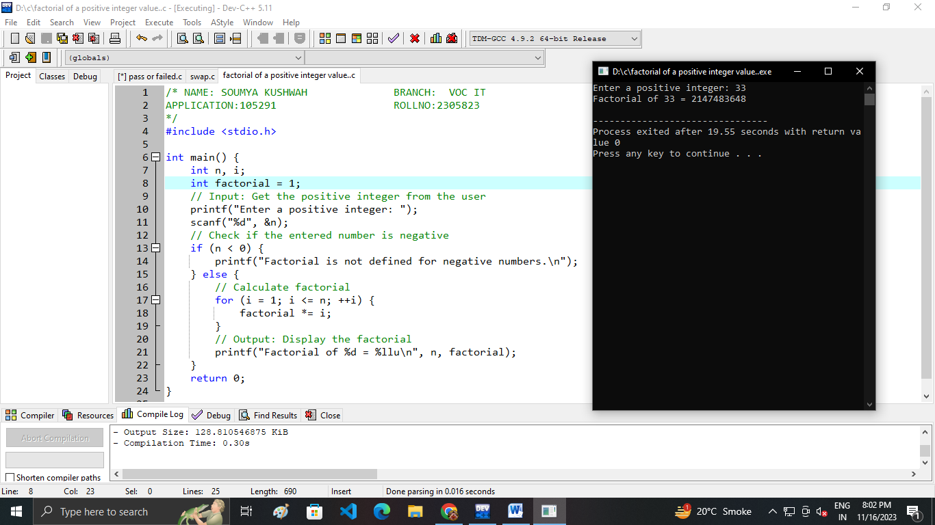

ROLL NO: 2305823 NAME: SOUMYA KUSHWAH
Program-8: Write a Program in C to get table of any positive integer value.
Algorithm: Create the table of a number
STEP 1. Start
STEP 2. Input the value of ‘b’ from the user
STEP 3. Initialize a variable ‘a’ to 1 (to represent the table multiplier)
STEP 4. Print a header for the table
STEP 5. While ‘a’ is less than or equal to a specified limit (e.g., 10):
- Calculate the product of ‘b’ and ‘a’ (product = ‘b’ * ‘a’)
- Print the table row: " ‘b’ x ‘a’ = product"
- Increment ‘a’ by 1
STEP 6. Stop
Source Code and output screen:
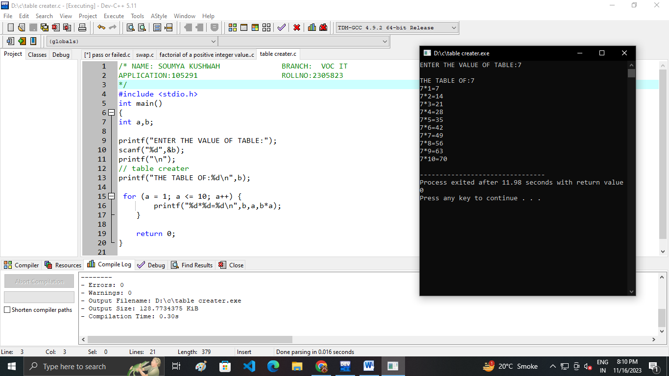

ROLL NO: 2305823 NAME: SOUMYA KUSHWAH
Program-9: Write a Program in C to find sum of digits.
Algorithm: Sum of digits
STEP1. Start
STEP2. Input the value of ‘number’ from the user
STEP3. Initialize a variable sum to 0 (to store the sum of digits)
STEP4. While ‘number’ is greater than 0:
- Get the ‘ last digit’ of ‘number’ ( ‘last Digit’ = ‘number’ % 10)
- Add ‘last Digit’ to the sum (sum = sum + ‘last Digit’ )
- Remove the ‘ last digit’ from ‘number’ ( ‘number’ = ‘number’ / 10)
STEP5. Print the sum as the result: "Sum of digits = sum"
STEP6. Stop
Source Code and output screen:
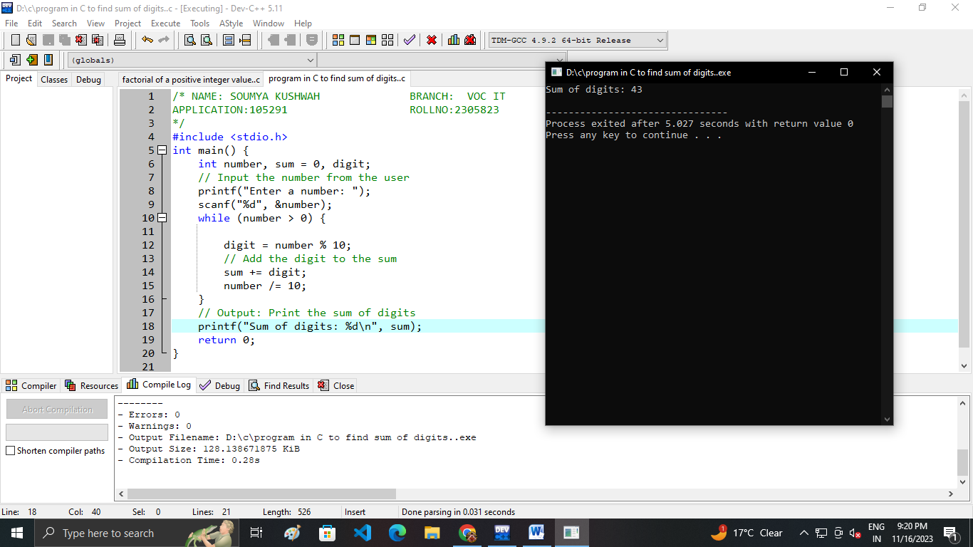

ROLL NO: 2305823 NAME: SOUMYA KUSHWAH
Program-10: Write a Program in C to check given number is Armstrong or not.
Algorithm: Check whether the number is Armstrong or not.
STEP1. Start
STEP2. Read the number 'n' from the user
STEP3. Set 'NUMBER' to 'n'
STEP4. Initialize 'result' to 0 and 'digits' to 0
STEP5. Count the number of digits:
While 'NUMBER' is not equal to 0:
STEP6. Increment 'COUNT' by 1
STEP7. Update 'NUMBER' by dividing it by 10
STEP8. Set 'NUMBER' back to 'n'
STEP9. Loop to calculate the sum of each digit raise to the power of 'COUNT':
While 'NUMBER' is not equal to 0:
STEP10. Get the last digit as 'remainder'
STEP11. Initialize 'power' to 1
STEP12. Loop 'i' from 1 to 'COUNT':
Multiply 'power' by 'remainder'
STEP13. Add 'power' to 'result'
STEP14. Update 'NUMBER' by dividing it by 10
STEP15. Check if 'result' is equal to 'n':
If true, print "n is an Armstrong number."
If false, print "n is not an Armstrong number."
STEP16. Stop

Source Code and output screen:
